1. **Introduction to Time Synchronization:**
   * Define time synchronization and its importance in computer networks.
   * Explain why accurate timekeeping is essential for various applications, including network security, logging, and distributed systems.
2. **Network Time Protocol (NTP):**
   * Overview of NTP:
     + Explain what NTP is and its purpose.
     + Describe the NTP architecture, including the roles of clients, servers, and stratum levels.
   * Synchronization Mechanism:
     + Discuss how NTP achieves time synchronization, including the use of reference clocks and synchronization algorithms.
   * Accuracy and Precision:
     + Explain the accuracy and precision levels that NTP can achieve.
   * Applications:
     + Discuss common applications of NTP, such as network logging, distributed databases, and financial transactions.
3. **Precision Time Protocol (PTP):**
   * Overview of PTP:
     + Explain what PTP is and its purpose, particularly in industrial automation and telecommunications.
     + Describe the PTP architecture, including the roles of grandmasters, ordinary clocks, and boundary clocks.
   * Synchronization Mechanism:
     + Discuss how PTP achieves time synchronization, including the use of hardware timestamps and synchronization messages.
   * Accuracy and Precision:
     + Explain the accuracy and precision levels that PTP can achieve, particularly in high-precision applications.
   * Applications:
     + Discuss specific applications of PTP, such as industrial automation, power systems, and telecommunication networks.
4. **Comparison Between NTP and PTP:**
   * Accuracy and Precision:
     + Compare the accuracy and precision levels of NTP and PTP.
   * Network Topology:
     + Discuss how NTP and PTP handle different network topologies, including scalability and fault tolerance.
   * Implementation Complexity:
     + Compare the complexity of implementing and configuring NTP versus PTP.
   * Applications and Use Cases:
     + Highlight the applications and use cases where each protocol is preferred based on its characteristics and requirements.
5. **Conclusion:**
   * Summarize the key differences between NTP and PTP.
   * Discuss the importance of selecting the appropriate time synchronization protocol based on the specific needs and requirements of the network or application.

This presentation outline should provide a comprehensive overview of NTP and PTP, their differences, and their respective applications.

**Network Time Protocol (NTP):**

* Overview of NTP

Network Time Protocol (NTP) is a networking protocol designed to synchronize clocks of networked computers. Its purpose is to ensure that all devices on a network agree on the time, which is crucial for coordinating actions, logging events, and managing data consistency across distributed systems.

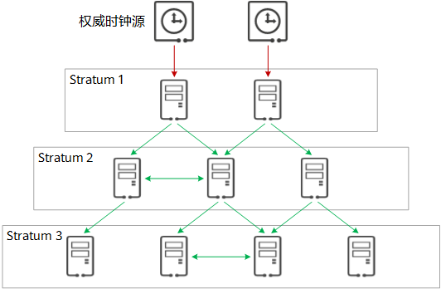

The NTP architecture is hierarchical, consisting of several layers called "strata." Here's a breakdown of the roles within this architecture:

Stratum 0: These are high-precision timekeeping devices such as atomic clocks or GPS clocks. They are not directly connected to the network but are used as reference clocks for stratum 1 servers.

Stratum 1: These servers are directly connected to stratum 0 devices. They are considered primary time servers and provide time to stratum 2 servers.

Stratum 2: These servers receive time from stratum 1 servers and provide synchronization to stratum 3 servers. They can also communicate with other stratum 2 servers to improve accuracy and reliability.

Stratum 3 and Beyond: These are servers and clients further down the hierarchy that synchronize time with the upper strata. The number can go up to stratum 15, with stratum 16 being unsynchronized.

* Synchronization Mechanism

NTP synchronizes time by exchanging time information between clients and servers. Clients send requests to servers, which respond with packets containing timestamps. These timestamps allow clients to calculate the round-trip delay and offset from the server's time.

The synchronization process involves several steps:

Polling: Clients periodically send requests to servers.

Timestamps: Each packet contains multiple timestamps: the client's departure time, the server's receive time, the server's transmit time, and the client's receive time.

Calculations: Clients use these timestamps to calculate the round-trip delay and the local clock offset.

Selection and Filtering: NTP uses complex algorithms to filter out outliers and select the best reference time.

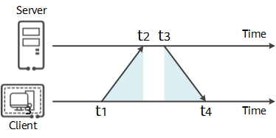

1. The client initially sends an NTP request message to the server, which includes the timestamp t1 when the message leaves the client.

2. The NTP request message arrives at the NTP server at timestamp t2. When the server receives this message, it processes and then sends out an NTP response message at timestamp t3. This response message carries the timestamp t1 when the message left the NTP client, the timestamp t2 when it arrived at the NTP server, and the timestamp t3 when it left the NTP server.

3. Upon receiving the response message, the client records the timestamp t4 when the message returns.

Using the aforementioned four timestamp parameters, the client can calculate two key parameters: the round-trip delay (delay) of the NTP message from the client to the server and the time difference (offset) between the client and the server. The NTP client adjusts its own clock based on the calculated offset to synchronize its clock with the NTP server.





* Accuracy and Precision

Accuracy: NTP can synchronize clocks to within milliseconds over the public internet and even better in well-configured local area networks (LANs), typically within tens of milliseconds.

Precision: The protocol's algorithms help maintain a high level of precision by adjusting the clock in small increments to avoid large, disruptive time corrections.

* Applications

Network Logging: Precise timestamps are crucial for diagnosing issues, ensuring that log entries from different sources are comparable.

Distributed Databases: Synchronization ensures that transactions are executed in the correct order and that time-based data is consistent.

Financial Transactions: Precise timekeeping is essential for time-stamping transactions, regulatory compliance, and avoiding disputes.

Telecommunications: Ensures synchronization in networks, which is vital for billing systems, network optimization, and service delivery.

**Precision Time Protocol (PTP):**

* Overview of NTP

Precision Time Protocol (PTP), defined by the IEEE 1588 standard, is designed to provide precise time synchronization across a network, especially in environments where high accuracy is crucial. Unlike NTP, which is designed for general-purpose time synchronization, PTP caters to applications requiring greater precision, such as industrial automation and telecommunications.

PTP Architecture:

Grandmaster Clocks: These are the primary reference clocks in a PTP network. All other devices synchronize their time to the grandmaster clock.

Ordinary Clocks: These are network devices that synchronize their clocks to the grandmaster clock or through other clocks in the hierarchy.

Boundary Clocks: These serve as intermediaries, capable of being both a time source and a time consumer. They help reduce the number of direct connections to the grandmaster and mitigate the impact of network topology on synchronization accuracy.

* Synchronization Mechanism

PTP achieves time synchronization through a series of messages and processes:

Synchronization Messages: PTP uses Sync messages to convey the current time of the grandmaster clock. Follow-Up messages provide additional time information to improve accuracy.

Delay Request and Delay Response Messages: These messages help measure the network delay between clocks, allowing for more accurate time adjustments.

Hardware Timestamps: PTP often utilizes hardware support for timestamping messages as they enter and exit a device, significantly enhancing accuracy by reducing software-induced latencies.

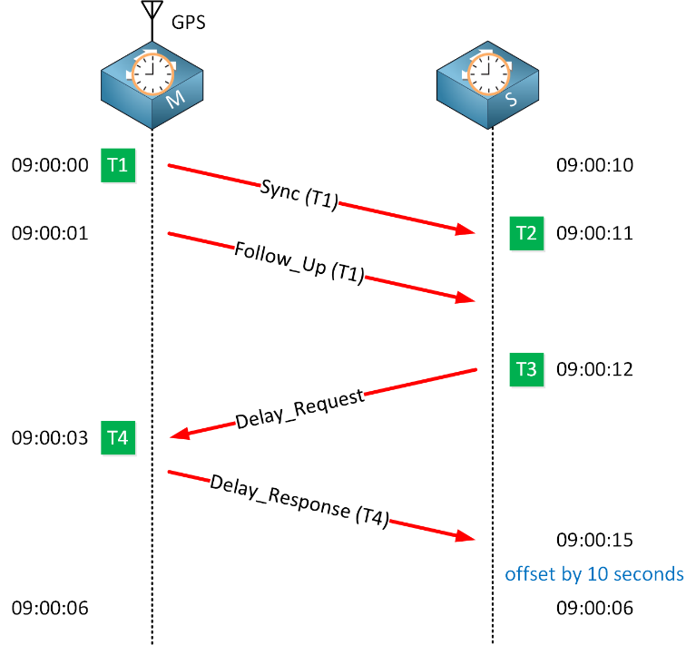





* Accuracy and Precision

PTP can achieve sub-microsecond synchronization accuracy in local networks, which is an order of magnitude improvement over NTP.

The protocol's design, especially the use of hardware timestamping, enables this high level of precision, critical in applications where even minor time deviations can lead to significant errors or inefficiencies.

* Applications

Industrial Automation: Precise time synchronization is vital for coordinating sensors, actuaries, and other components in automated manufacturing processes.

Power Systems: In smart grids, accurate time stamps are essential for fault detection, load balancing, and efficient energy distribution.

Telecommunication Networks: PTP is used to ensure synchronization across various elements of a network, crucial for maintaining the quality and reliability of voice, data, and video communications.